**Domain:** btob.btobjob.com

**FOOTER:**Re-Align the logo and its position correctly:





**Button**: Tariffs/Découvrir

After clicking on this button it prompts me to select from particular or professional but there is not any option to cancel it even if I reload same thing opens, I press (Arrow Back or Go Back) button and it still takes me to the same page (particular or professional choosing page).

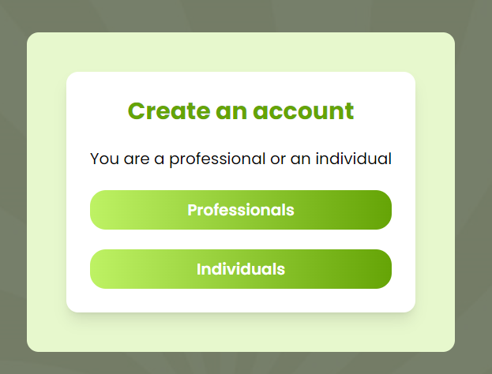



**Correction:** Add a cancel button which cancels or removes the pop-up and loads me the last page I was on.

**Button:** Contact

After clicking on this button, a page opens to enter my details and send a message.

After clicking “Envoyer Message” button the below picture box opens.

**Correction:** Change the “traduire” phrase to “Confirmer”

**Button:** The ‘F.A.Q.’ Page, have a bar with a button to find help. The button doesn’t seem to work not opens/changes or redirects to any page or question or anything.

**Correction:** Make the button functionable.

Same page, there is a button in front of every Question, i.e.:



But the marked button doesn’t seem to work and is not working.

**Correction:** Make the Button functionable and when on visiting this page the answer are hidden first, only questions in “Bold Text” above are seeable. Only when the visitor clicks on this marked button then the answer will appear.

**Page:** Accueil (Homepage)

The below marked buttons do not work nor the button after Professional works neither does the Service men (box) works on clicking.

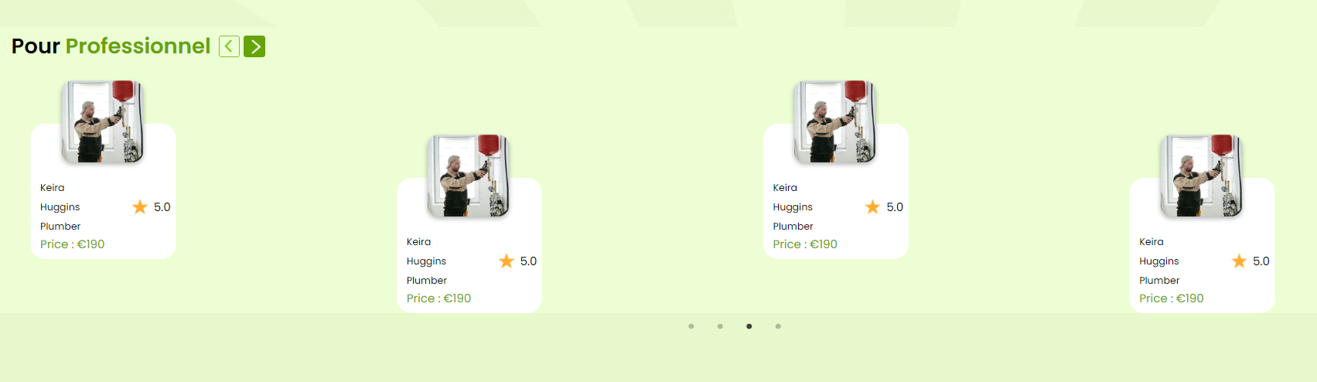

**Correction:** Make the arrow button workable, they can shift the below appearing professionals.

Secondly, the professionals appearing in boxes, if a user comes and clicks them (before logging) it opens the below pop-up box:



**Button:**

The button mentioned below marked in the picture takes us to the Contact page.

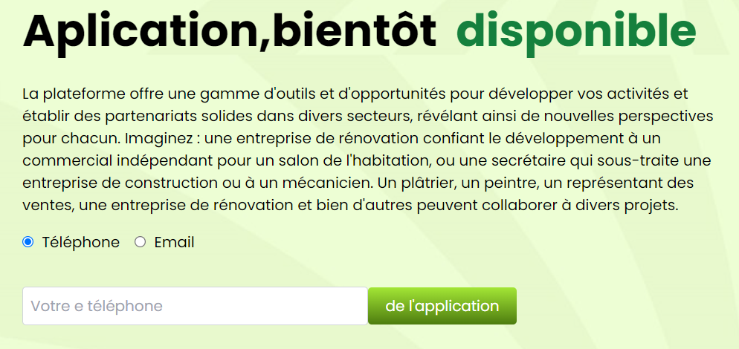

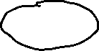

**Correction:** Remove the un-necessary usage boxes and options and just let there be a button to redirect to the Contact page, Rename the button to: ” S'abonner”

**Page:** Homepage

The below mentioned area of the Homepage or Accueil Page, in this page both the “Envoyer une” and “Save it” buttons are not functionable.

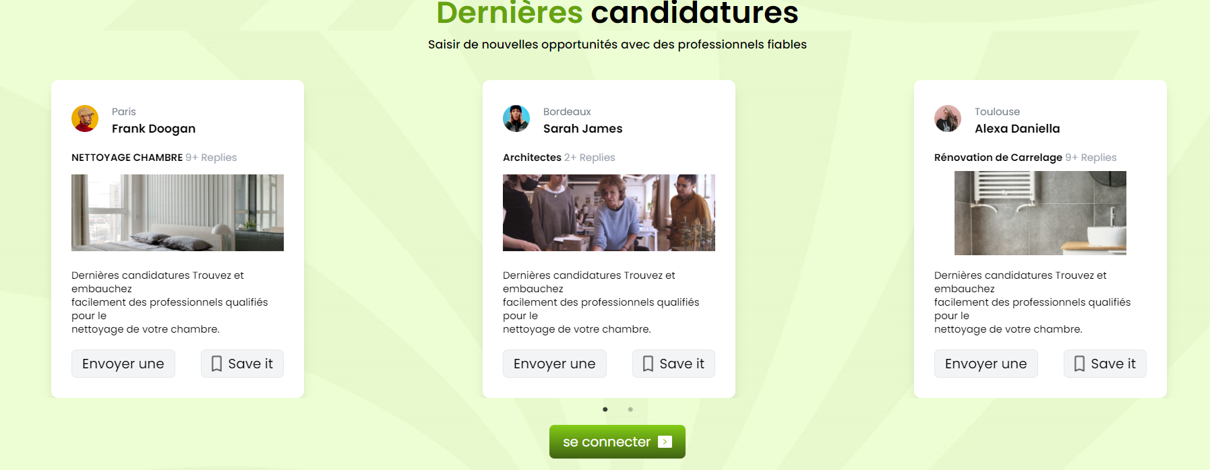



**Correction:**

Make both buttons functionable with as well as following changes:

Change the “Save it” phrase to “Sauvegarder”

Change the “Envoyer une” phrase to “Envoyer un message”

On Clicking, “Envoyer un message” or “Sauvegarder” the website takes you to the Create an Account Page: The pop-up page that appears where you have to choose between **Particular and Professional**.

**Page:** Create an Account “Particular or Professional Page”, in this pop-up when I click on the Professional, it prompts me to create an account for as a professional, while when I click on “se connecter” button it doesn’t take me anywhere nor the page changes.

**Correction:** Make the button workable and functionable and should take me to the login page for a professional.

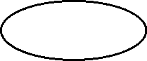

**Page:** Same page, “Create an Account”, now on this page, when I click Particular (for registering)

Firstly, for the registering box if I don’t enter any detail or fill any field the text comes in English wordings,

Like: Please enter your name, Please enter your email, etc.

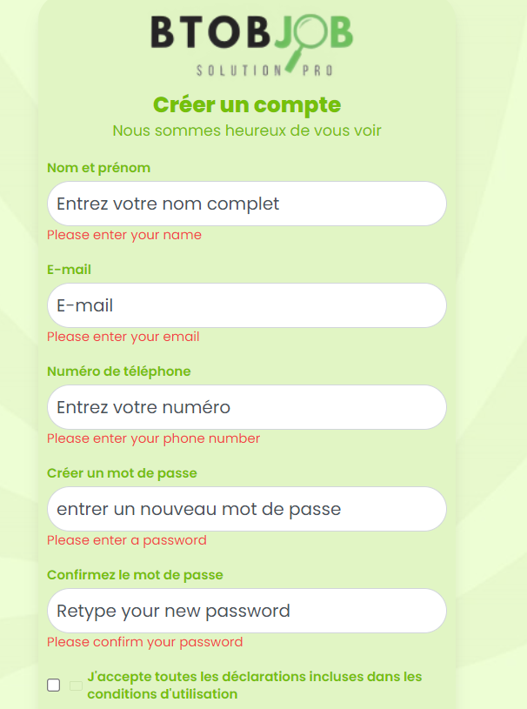



**Correction:** They should all come in French wording.

The forgot password button on the login or ‘se connecter’ page of the **“Particular”** page doesn’t work and is giving below error:

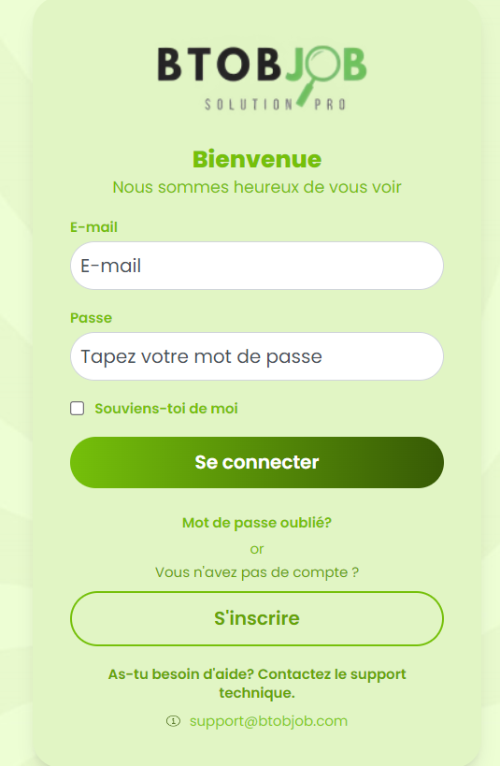



**Correction:** Make the forgot password button mentioned or marked in the above picture functional and working.

On the **“Se Connecter”** page of the **“Particular”** page of the Creation Page, when I click on the **“S’inscrire”** button it takes me to the choosing option pop-up page of: **Particular or Professional Pop-up Page**, rather it should take me to the registering page of the Particular.

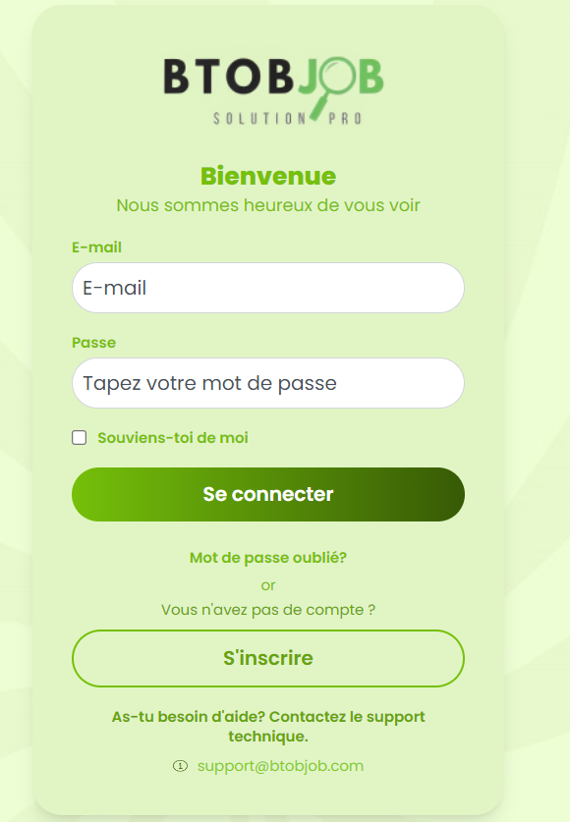

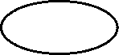

**Correction:** Fix the redirection of the **“Se connecter”** page of the Particular registration and it should take me to the correction Registration page when I click on **“S’inscrire”**.